PROGRAM 8 :Energy Conservation Before-and-After Analysis
1. Problem statement
A college wants to evaluate the effectiveness of an energy conservation program. Electricity usage is recorded for appliances before and after the intervention. Develop a Python program that calculates the energy saved by each appliance, computes savings percentages, ranks appliances by their savings, and displays the overall energy reduction.
2. Objectives
- Store appliance names and electricity usage before and after the intervention.
- Calculate energy savings for each appliance.
- Calculate the percentage reduction in electricity consumption.
- Rank appliances according to their energy savings.
- Display total consumption and overall savings.
3. Assumptions and rules
Electricity usage is measured in kilowatt-hours (kWh) over the same period.
Appliance | Before (kWh) | After (kWh)
Air Conditioner | 120 | 84
Lighting | 60 | 36
Computers | 100 | 70
Fans | 40 | 30
Projector | 30 | 24
Rules:
- Energy saved = Before usage − After usage.
- Savings percentage = (Energy saved ÷ Before usage) × 100.
- Appliances are ranked from highest to lowest energy saved in kWh.
- Overall savings percentage is calculated using total energy saved divided by total usage before the intervention, multiplied by 100.
- Before-usage values must be greater than zero, and usage values cannot be negative.
4. Computational thinking
- Decomposition: Divide the problem into recording usage, calculating savings, calculating percentages, ranking appliances, and preparing a report.
- Pattern recognition: Identify which appliances show the largest reductions in electricity consumption.
- Abstraction: Focus on appliance names and electricity usage before and after the intervention.
- Algorithmic thinking: Calculate savings for each appliance, sort the results, and calculate the overall reduction.
5. Algorithm
- Start the program.
- Store appliance names and electricity usage before and after the intervention.
- Initialize totals for before-usage, after-usage, and energy saved.
- For each appliance, calculate energy saved and savings percentage.
- Store the calculated results.
- Sort appliances by energy saved in descending order.
- Calculate total energy saved and overall savings percentage.
- Display appliance-wise results, rankings, and overall savings.
- Stop the program.
6. Flowchart
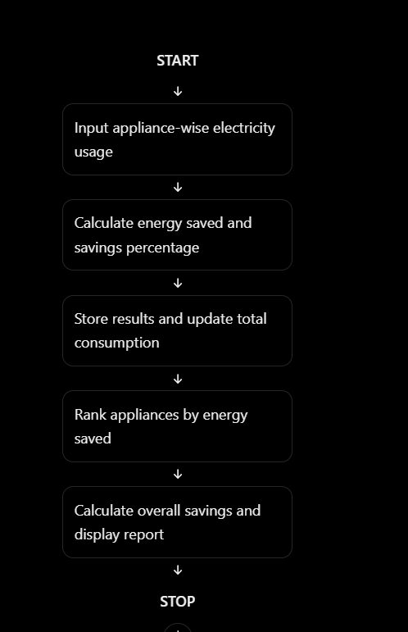

7.PESUDO CODE
START

Store appliance names
Store electricity usage before and after intervention

Set total_before = 0
Set total_after = 0
Set total_saved = 0

FOR each appliance
IF before usage <= 0 OR after usage < 0
Report invalid data
ELSE
saved = before usage - after usage
percentage = (saved / before usage) * 100

Store appliance results
Update total_before
Update total_after
Update total_saved
END IF
END FOR

Sort appliances by energy saved in descending order

overall_percentage = (total_saved / total_before) * 100

Display appliance rankings
Display overall savings

STOP

8.PYTHON SOURCE CODE

# Energy Conservation Before-and-After Analysis

appliances = [
("Air Conditioner", 120, 84),
("Lighting", 60, 36),
("Computers", 100, 70),
("Fans", 40, 30),
("Projector", 30, 24)
]

results = []

total_before = 0
total_after = 0
total_saved = 0

print("===== ENERGY CONSERVATION ANALYSIS =====")

# Calculate savings for each appliance
for appliance, before, after in appliances:

# Validate input values
if before <= 0 or after < 0:
print("Invalid data for:", appliance)
continue

saved = before - after
percentage = (saved / before) * 100

results.append((appliance, before, after, saved, percentage))

total_before += before
total_after += after
total_saved += saved

# Rank appliances by energy saved
results.sort(key=lambda item: item[3], reverse=True)

print("\n===== APPLIANCE-WISE RESULTS =====")

for appliance, before, after, saved, percentage in results:
print("\nAppliance:", appliance)
print("Before usage:", before, "kWh")
print("After usage:", after, "kWh")
print("Energy saved:", saved, "kWh")
print("Savings percentage:", round(percentage, 2), "%")

# Display ranking
print("\n===== SAVINGS RANKING =====")

for rank, item in enumerate(results, start=1):
print(rank, ".", item[0], "-", item[3], "kWh saved")

# Calculate overall savings
if total_before > 0:
overall_percentage = (total_saved / total_before) * 100
else:
overall_percentage = 0

print("\n===== OVERALL SUMMARY =====")
print("Total before usage:", total_before, "kWh")
print("Total after usage:", total_after, "kWh")
print("Total energy saved:", total_saved, "kWh")
print("Overall savings:", round(overall_percentage, 2), "%")

print("\nAnalysis completed.")

9. Test cases
Test case | Before (kWh) | After (kWh) | Expected result
1 | 100 | 70 | 30 kWh saved; 30% savings
2 | 80 | 80 | 0 kWh saved; 0% savings
3 | 50 | 60 | −10 kWh savings; 20% increase in usage
4 | 0 | 0 | Invalid before-usage value
5 | 100 | −5 | Invalid negative usage
10. Expected output
===== ENERGY CONSERVATION ANALYSIS =====

===== APPLIANCE-WISE RESULTS =====

Appliance: Air Conditioner
Before usage: 120 kWh
After usage: 84 kWh
Energy saved: 36 kWh
Savings percentage: 30.0 %

Appliance: Lighting
Before usage: 60 kWh
After usage: 36 kWh
Energy saved: 24 kWh
Savings percentage: 40.0 %

Appliance: Computers
Before usage: 100 kWh
After usage: 70 kWh
Energy saved: 30 kWh
Savings percentage: 30.0 %

Appliance: Fans
Before usage: 40 kWh
After usage: 30 kWh
Energy saved: 10 kWh
Savings percentage: 25.0 %

Appliance: Projector
Before usage: 30 kWh
After usage: 24 kWh
Energy saved: 6 kWh
Savings percentage: 20.0 %

===== SAVINGS RANKING =====
1 . Air Conditioner - 36 kWh saved
2 . Computers - 30 kWh saved
3 . Lighting - 24 kWh saved
4 . Fans - 10 kWh saved
5 . Projector - 6 kWh saved

===== OVERALL SUMMARY =====
Total before usage: 350 kWh
Total after usage: 244 kWh
Total energy saved: 106 kWh
Overall savings: 30.29 %

Analysis completed.
11. Conclusion
The program compares electricity consumption before and after an energy conservation intervention. It calculates appliance-wise savings, determines percentage reductions, ranks appliances by energy saved, and reports overall energy conservation. The results help identify where the greatest reductions in electricity usage occurred.

